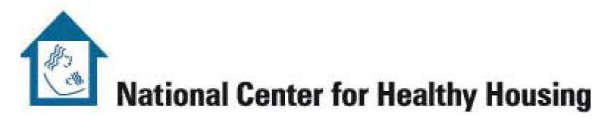
Code Enforcement for Healthier Homes

Agenda: City, State, Date

Welcome/Introductions/Expectations??

Overview Part I: Identifying Hazards-Making the Connection
- Group Exercise #1-Making the Connection
- Guiding Principle of Codes and Healthy Housing, what is the Connection?

Break

Overview Part II: Identifying Hazards-Making the Connection Continued
- Holistic Approach to Code Inspections
- Evaluation of Current Code Inspection Practices to Identify Hazards to Health

Lunch

Introduction of International Property Maintenance Code relevant to healthy homes
- American Housing Survey (AHS)-comparison to local conditions
- Top five code violations in (state where training being held)?
- How does the AHS compare to the top five code violations in (state where training being held)?

Break

Property Maintenance Code Continued
- International Property Maintenance Code in (state of training)
- Examples of Housing Code Checklists
- Group Exercise #2: Identify the Code Violations and responsible party
- Case Studies

Code Enforcement Strategies: Awareness of Additional Issues
- Environmental Hazards
- Landlord-Tenant Law
- Referral Process for Legal Aid
- Exercise #3: Identifying Policies/Practices to Support Healthy Homes (Review Current Algorithm of Code Process)

Wrap-up, Review, Course Evaluation

Adjourn

