Module 4:

Evaluate Health Impacts

This Module is designed to teach Assessors/Inspectors the importance of the relationship between hazard rating and health impacts when using the HUD Healthy Home Rating System (HHRS).

Learning Objectives

By the end of this module, students will be able to:

The HHRS Process

As we begin this module, let’s review the HHRS process. The HHRS is a four step process that includes:

**Review of Key Principles**

The HHRS tool is used to determine the level of risk to occupants’ health and safety based on the hazards that are present in the home. The key principle of the HHRS is that a dwelling should be safe and healthy for ANYONE who occupies the dwelling, including visitors.

Your assessment tool of choice is still used to assess the deficiencies in the home and the HHRS tool will be used after the assessment to determine the health and safety risks to occupants and to assist you in prioritizing interventions. All hazards should be documented; do not avoid documenting a hazard because of concerns regarding available resources to fix the problem later.

Categories of Hazards

There are 4 main categories of hazards using the HHRS. The main categories of hazards are from the American Public Health Association’s (APHA) 1938 publication titled “Basic Principles of Healthful Housing.” The specific hazards have changed (see current list of 29 hazards), but not the four specific categories considered essential for human health:

* Physiological Hazards
* Psychological Hazards
* Protection Against Infection
* Protection Against Accidents

Each individual hazard is placed in a particular category based on the effect it may have on occupants. Appendix C of the *Operating Guidance* contains the full list.

The HHRS Formula

There are three figures used to generate a hazard score:

1. A weighting for each Class of Harm reflecting the degree of incapacity to the victim resulting from the occurrence.
2. The likelihood of an occurrence involving a member of a vulnerable group, expressed as a ratio.
3. The spread of possible harms resulting from an occurrence, expressed by percentage for each of the four Classes of Harm.

The weighting for Classes of Harm are fixed numbers that do not require input from the Assessor/Inspector. The Assessor/Inspector does consider likelihood and possible harm.

**Two Judgments by Assessor/Inspector**

The HHRS requires the Assessor/Inspector to make two judgments for each hazard identified during the assessment. Once you have assessed the home and determined the hazards caused by the deficiencies, you will then determine the likelihood, spread of harms, and hazard score for those hazards that may pose the most significant threat to the occupants, considering vulnerable populations. Making likelihood judgments can be difficult and confusing; be patient!

First Judgment: Likelihood

The first judgment that the Assessor/Inspector must make involves determining the likelihood, over the next 12 months that a hazard could harm a member of the vulnerable group.

For each of the 29 HHRS hazards, average likelihoods in the UK are provided when data is available according to dwelling type and age. The actual likelihood is going to vary based on the Assessor/Inspector’s judgment of the conditions in that particular dwelling.

Based on the deficiencies in the home identified during the assessment (considering extent/severity of hazard, and location in dwelling), the Assessor/Inspector determines whether or not the likelihood of an occurrence will be increased or decreased (a greater chance of an occurrence or less of a chance of an occurrence) from the provided national averages.

**Judging Likelihood**

Think of this idea in terms of using a scale of 1 to 10. A score of 1 would be used when a risk is extremely likely to occur (a 1 in 1 chance) and a score of 10 would be used when the risk is extremely unlikely to occur (a 1 in 10 chance).

In the case of HHRS, there are 16 likelihood choices instead of 10; box 1 being when a risk is the least likely (a 1 in 5600 chance) to occur and box 16 being when a risk is the most likely to occur (a 1 in 1 chance).



The Assessor/Inspector is not expected to give an exact likelihood ratio, but to select one of the 16 standard HHRS likelihood ranges, such as the range of 1 in 24 to 1 in 42; or the range of 1 in 420 to 1 in 750.

Assessing likelihood is **not** determining or predicting that there **definitely** will be harm

Assessing likelihood is not determining or predicting that there definitely will be harm. Even where it is judged that there is a very high likelihood, such as a 1 in 10 probability, it is still accepting that the likelihood of no occurrence is nine times greater than that of an occurrence. The purpose of the HHRS is to determine **risks** to health and safety. For example, with 1 in 24 likelihood (0.0416) or 1 in 42 likelihood (0.0238), harm from a hazard is not expected.

The purpose of the HHRS is to determine **risks** to health and safety

Another way to think of the likelihood ranges is in months. For the range of 1 in 24 or 1 in 42, an Assessor/Inspector could think of it as an occurrence happening once in the next 24 months or once in the next 42 months.

**Likelihood Numbers**

Where data is available, individual hazard profiles give United Kingdom (UK) average likelihood numbers for different age groups and types of dwellings. These numbers are averages which represent the likelihood for the typical condition that could be expected in a dwelling of that particular age and type. Also provided in the hazard profiles is guidance on dwelling characteristics that may affect the likelihood of an occurrence.

(Need note here on second bullet on slide?) Only assess hazards that presently cause, or are likely to cause harm, over next 12 months.

The provided UK likelihood numbers are meant as a reference. The U.S. Department of Housing and Urban Development (HUD) will begin updating this likelihood and outcome data.

**Example: Likelihood for Mold & Moisture**

During an assessment, an Assessor/Inspector notes that there is no exhaust fan in the bathroom and a leaking sink. The Assessor/Inspector therefore judges that dampness and mold is a greater hazard in this apartment than the national average (remember extent/severity of deficiencies as well as location). The Assessor/Inspector should now asses the collective likelihood of an occurrence.

**C:\Users\lfudala\AppData\Local\Microsoft\Windows\Temporary Internet Files\Content.IE5\MTO1QXB8\MC900211979[1].wmfRememberC:\Users\lfudala\AppData\Local\Microsoft\Windows\Temporary Internet Files\Content.IE5\MTO1QXB8\MC900211979[1].wmf**

Box1 = least likely (1 in 5600 chance)

Box 16 = most likely (1 in 1 chance)

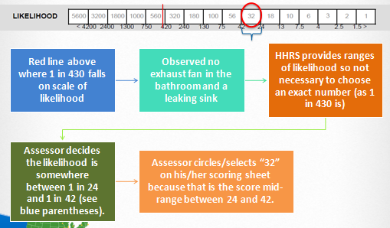

The red line in the graphic above represents the national average for dampness and mold as listed on the individual hazard profile. Using observations during the home assessment (no exhaust fan and leaking sink in bathroom) the Assessor/Inspector decides that the likelihood this hazard will cause harm over the next 12 months is somewhere between 1 in 24 and 1 in 42. This leads to a score mid-range between 24 and 42, 32 - the representative scale point. The representative scale point is the number used in the hazard rating formula to calculate the hazard score. This will also be true for spread of harm outcomes in the next section.

**Determining Likelihoods**

It is important to remember that as Assessors/Inspectors go through the process of determining likelihoods there are no “correct” or “incorrect” likelihood choices; the likelihoods chosen are based on the professional judgment of the Assessor/Inspector. As this course progresses and the process for calculating the scoring is reviewed, it will become clear that Assessors/Inspectors can have a reasonable degree of differences but end up with a similar Hazard Score. When determining likelihoods, be patient and focus on the rationale or **justification** of the likelihood score chosen.

Second Judgment: Outcomes

When calculating the Hazard Score, the more serious the outcome, the heavier the weighting. The weighted calculation is done for you in the HHRS assessment program. The only time an Assessor/Inspector will use it is if they decide to do the math longhand. This section explains how the formula works.

**Classes of Harm (Harm Outcomes)**

Appendix B of the *Operating Guidance* contains detailed in formation regarding HHRS Classes of Harm. The following graphics list examples of harms from each of the four categories:

**Assessing the Outcomes**

**Example: Outcomes for Excess Heat**

Page 63 of the *Operating Guidance* contains the hazard profile for Excess Heat.

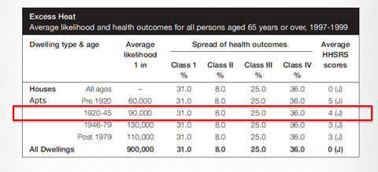

Using the hazard profile information (see above), an Assessor/Inspector then would complete the spread of harm section of the HHRS scoring sheet (see below).

The “classes” along the left side of the scoring sheet (represented above) are the 4 HHRS Classes of Harm from page 33 of the *Operating Guidance*. The numbers above and below the boxes are the likelihood ranges. The numbers inside the boxes are the representative scale points.

When scoring, the following guidelines are followed:

* Consider how the deficiencies contribute to harm in each Class.
* Unless the conditions call for adjusting the outcomes, they should be accepted as-is.
* The sum of the classes will total 100%.

Keep in mind, the resulting outcomes for each hazard are not specific to region or location, but reflect the impact those hazards have on human health generally.

**The Numerical Score**

Based on our Case Study #3, let’s compute the numerical score.

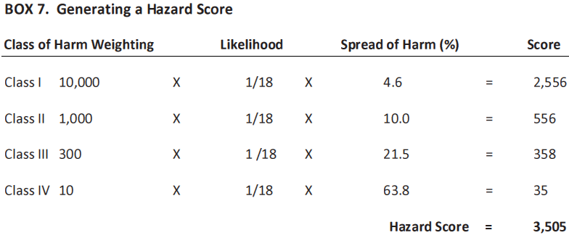

In practice, these calculations do not have to be done by hand; the Excel software will complete the calculations after the Assessor/Inspector inputs the appropriate information.

**The Result – Hazard Bands**

Hazard bands were devised to avoid having the emphasis placed on what may appear to be a precise numerical hazard score. There are 10 hazard bands identified on page 19 of the *Operating Guidance*. Band A represents the most dangerous; Band J represents the least dangerous.

|  |  |
| --- | --- |
| Band | Score |
| A | **5,000 or more** |
| B | **2,000 to 4,999** |
| C | **1,000 to 1,999** |
| D | **500 to 999** |
| E | **200 to 499** |
| F | **100 to 199** |
| G | **50 to 99** |
| H | **20 to 49** |
| I | **10 to 19** |
| J | **9 or less** |

Hazard Bands also provide a simple means for handling the potentially wide range of scores: from under 0.2 to 1,000,000. Based on the previous Case Study #3, what is the Hazard Band for that hazard? It’s a “B” band hazard; the second most serious.

Hazard bands are utilized as the numerical Hazard Score can appear too specific. Numerical scores can also falsely imply that the score is a precise statement of the risk, rather than a representation of the assessor’s judgment.

Practice: Determining Likelihoods, Outcomes, Hazard Scores, and Bands

Let’s take a moment to remember the first two steps of the HHRS process:

Now we are on Step 3: Evaluating the significant health impacts related to the hazards found in the dwelling; also known as scoring the hazard.

**Scoring a Hazard: the Complete Process**

Using the scoring tool available on HUD’s website, and everything presented so far in this module, let’s practice:

1. Determining the hazard
2. Determining likelihood and outcomes
3. Determining the hazard band

The pictures below are the same ones used in Module 3 to connect deficiencies to the appropriate HHRS hazard. These pictures will now be used to consider how the deficiency contributes to Spread of Harms.

Exercise

Review